**Specification Sheet**

**M12 Magnetic Proximity Sensor**

|  |  |
| --- | --- |
| Model | **KCB-R-59122** |
| Switching Voltage | **≤300V DC** |
| Operate Time | **≤4.0ms** |
| Output | **2-wire NO** |
| Temperature range | **-10℃~60℃** |
| Current | **≤2A** |
| Response time | **≤1.0ms** |
| Longevity | **≥5x10**7 |
| Release time | **≤0.4ms** |
| Operating principle | **Magnet reed** |
| Electrical longecity | **≥10**7 |
| Frequency | **≤185Hz** |
| Vibration | **≤50g/11ms** |
| Sheath material | **ABS** |
| Sensing distance | **5-20mm** |

* **Dimension**  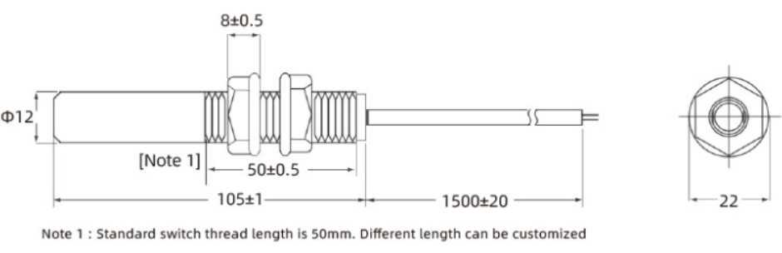

**Picture**

